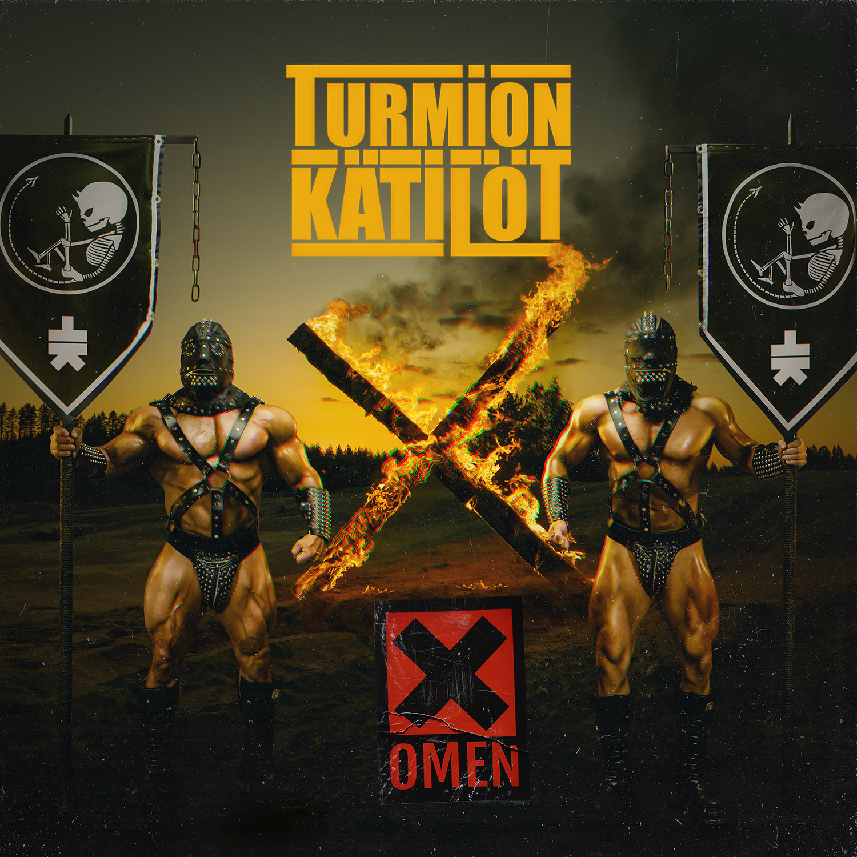
TURMION KÄTILÖT
NEW ALBUM “OMEN X” OUT January 13th 2023!

LINE-UP:
Mc Raaka Pee – Vocals | Shag-U – Vocals | Bobby Undertaker – guitars
Master Bates – bass guitar | Run-Q - synthesizers & keyboards | Dq – drums

After 9 full length studio albums and playing their asses off at over 800 shows, the Finnish disco metal machine Turmion Kätilöt is ready for the next level in their world dominance. Their 10th full length studio album “Omen X” will be released in 36 countries on 13th January 2023 via Nuclear Blast. The touring cycle starts in Finland immediately after the release of Omen X. Band will play its biggest show ever in Helsinki Ice hall on 14th January 2023. After couple of shows in the home country “Omen X” will be served all over Europe with 20 gigs inFebruary 2023 – see the full show schedule below.
”In the Omen X production, we encountered only positive problems. Due to the closures caused by Covid 19, there were so many songs available this time that it was even painful to choose only one album of songs from them. The amount of material and the difficulty of selection seemed to take up an unnecessary amount of valuable studio time at times. Otherwise, making the album went smoothly as always. From the artist's point of view, the album got a hell of a new sounds and atmosphere. A very cleansing experience. The tenth prophecy has been given. You're welcome!” - MC Raaka Pee
Turmion Kätilöt was formed in 2003 in Finland by MC Raaka Pee and Dj Vastapallo. Soon they were joined by the other members of what would become Turmion Kätilöt: Master Bates, Run-Q, DQ and Spellgoth as a second vocalist. With a couple of line-up changes as Dj Vastapallo left the band in 2009 replaced by Bobby Undertaker on guitars (ex-Deathchain) and Spellgoth leaving in 2017 replaced by Shag-U (Fear Of Domination) on vocals, Turmion Kätilöt has become the mean disco metal machine they are today.
From the very beginning Turmion Kätilöt has had a reputation of being a great live band. Disco beats from the 90’s, metal to the pedal, melodies, sing-a-longs, you name it – there are no rules. Yet still if you peek under the skin you can find the darkness pointing its finger to you. Their live shows have been praised to be the fiercest and craziest mayhem to be witnessed creating the twisted world of Turmion Kätilöt. Come and embrace your true self – catch the band live here:

SUPPORTING NIGHTWISH ON HUMAN :||: NATURE TOUR 2022
20.11.2022 BE Antwerp, Lotto Arena
21.11.2022 UK London, SSE Arena Wembley
22.11.2022 UK Birmingham, Resorts World Arena
23.11.2022 IE Dublin, 3Arena
25.11.2022 DE Berlin, Max-Schmeling-Halle
27.11.2022 NL Amsterdam, Ziggo Dome
28.11.2022 NL Amsterdam, Ziggo Dome
30.11.2022 FR Paris, Accor Arena
01.12.2022 DE Dusseldorf, PSD Bank Dome
02.12.2022 LU Luxembourg, Rockhal
04.12.2022 AT Vienna, Stadthalle
05.12.2022 DE Münich, Olympiahalle
06.12.2022 IT Milan, Lorenzini District
09.12.2022 DE Frankfurt, Festhalle
10.12.2022 DE Bamberg, Brose Arena
12.12.2022 DE Hamburg, Barclays Arena
13.12.2022 DE Leipzig, Quarterback Immobilien Arena
14.12.2022 PL Gliwice, Arena
16.12.2022 CH Zürich, Hallenstadion
18.12.2022 DE Stuttgart, Hannis-Martin-Schleyer-Halle
20.12.2022 HU Budapest, Sportarena
21.12.2022 CZ Prague, O2 Arena

OMEN X WORLD TOUR 2023
03.02.2023 NO Oslo, John Dee
05.02.2023 SE Stockholm, Hus 7
06.02.2023 SE Gothenburg, Valand
08.02.2023 DE Hamburg, Markthalle
09.02.2023 DE Berlin, Frannz
10.02.2023 PL Wroclaw, Akademie
12.02.2023 DE Leipzig, Hellraiser
13.02.2023 CZ Prague, Storm Club

14.02.2023 AT Vienna, Chelsea
16.02.2023 HU Budapest, Barba Negra
18.02.2023 DE Münich, Backstage
19.02.2023 DE Stuttgart, Im Wizemann Club
20.02.2023 IT Milan, Legend Live Club
22.02.2023 FR Paris, La Maroquinerie
23.02.2023 DE Oberhausen, Kulttempel
25.02.2023 BE Vosselaar, Biebob
26.02.2023 NL Utrecht, De Helling
27.02.2023 DE Cologne, Club Volta
01.03.2023 DE Frankfurt, Das Bett
02.03.2023 CH Zürich, Dynamo

Discography and album chart peak history in Finland
2020 – Global Warning #1 (gold record sales in Finland reached)
2018 – Universal Satan #1 (gold record sales in Finland reached)
2017 – Dance Panique #4 (gold record sales in Finland reached)
2015 – Diskovibrator #1 (gold record sales in Finland reached)
2013 – Technodiktator #4 (gold record sales in Finland reached)
2011 – Perstechnique #6
2009 – U.S.C.H.! #6
2006 – Pirun Nyrkki #7
2004 – Hoitovirhe #28 (gold record sales in Finland reached)

Awards:

2021 – Emma gala nominee for the best band of the year
2021 – Emma gala nominee for the best metal album of the year
2018 – Emma gala nominee for the best metal album of the year
2017 – Oulu Music Video Festival, Best music video (public voting)
2016 – Femma Awards, Best artist (public voting)
2015 – Finnish Album Chart, week 40, best selling album
2015 – Femma Awards, Best artist (public voting)
2014 – Finnish DVD chart, week 51, best selling music DVD
2014 – Femma Awards, Best artist (public voting)
2010 – Femma Awards, Best artist (public voting)
2004 – Muuvi Awards, Commendation for weirdest music video of the year

Contacts:
Booking in Finland: rowan@nem.fi
Booking and management in rest of Europe: aino@tdtc.fi
Label: oleg@nuclearblast.co.uk

nuclearblast.de | tdtc.fi | turmionkatilot.com | nem.fi
facebook.com/turmionkatilot | instragram.com/turmion_katilot_official
photos for press use: turmionkatilot.com/contact

